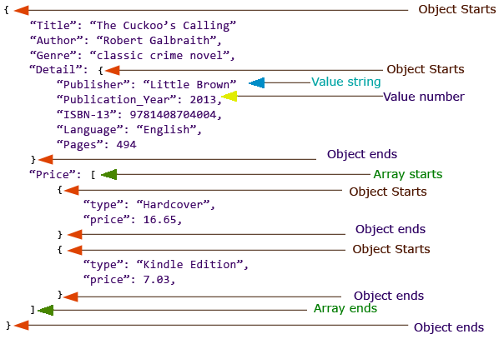

|  |
| --- |
| {  “products”: [  {  “name”: “PC1”,  “description”: “Een mooie PC”  },  {  “name”: “PC2”,  “description”: “Een heel mooie PC”  }  ]  } |